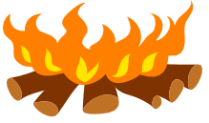HEAT REVISION

1. What happens to cause these:
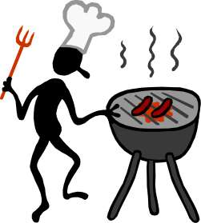
- conduction

- convection

- expansion

- contraction

- Complete the following sentences using the words “convection, conduction, radiation”.

- In boiling water the heat is transferred through the water by ________________. Heat is transferred through a metal spoon by ________________. Heat is transferred to the earth, from the sun, by _________________.

- How do particles move in solids, liquids and gases?
- solids:

- liquids:

- gases:

4. a. Name 3 good conductors:

- Name 3 insulators:

- Why are insulators often used next to conductors? eg. The plastic handle on a metal saucepan.

- Place these colours in order from best absorber to best reflector.

‘shiny silver, grey, matt black, gloss (shiny) black, white, orange’

- How does the design of a thermos flask make it extremely good at slowing down heat loss?

- What features of an efficient house enable it to save energy?

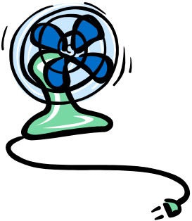
- How does a thermometer work?

- Compare ice, water and steam and explain why these substances have very different properties by referring to the movement of molecules.

- Explain how a solar hot water system works

- Give definitions for the following terms:
  - Freezing
  - Boiling
  - Condensing
  - Subliming
  - Melting

- Heat moves around using three methods. What are the names of these three methods and how does each work?

- The Kimberley has the highest percentage of white cars than anywhere else in Australia. Explain why using your knowledge of heat.

12. Jump on a computer and go to this webpage:

http://www.schoolscience.co.uk/content/3/chemistry/materials/index.html

Read through pages 1 to 9 and then have a go at the quiz questions……..

- Browse to “Student Resources”, “Science”. “Lower School”, “Year 9”, “Heating & Cooling” and click on the PowerPoint show called “States of Matter”. There will be some questions from this in the test on Friday.

